Power BI Hands on Assessment

# Loading Of Data

Step 1: Open up ***SQL Server 2014 Management*** for loading of data

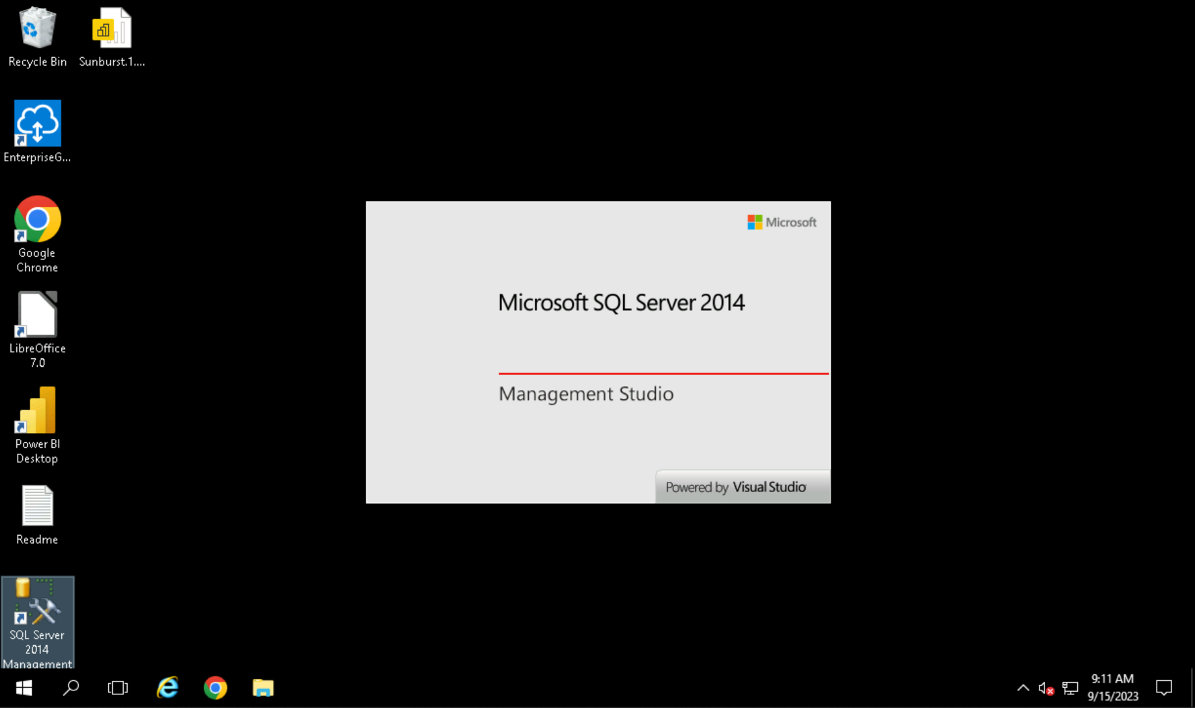

Step 2: Click on the “*connect*” to connect to server

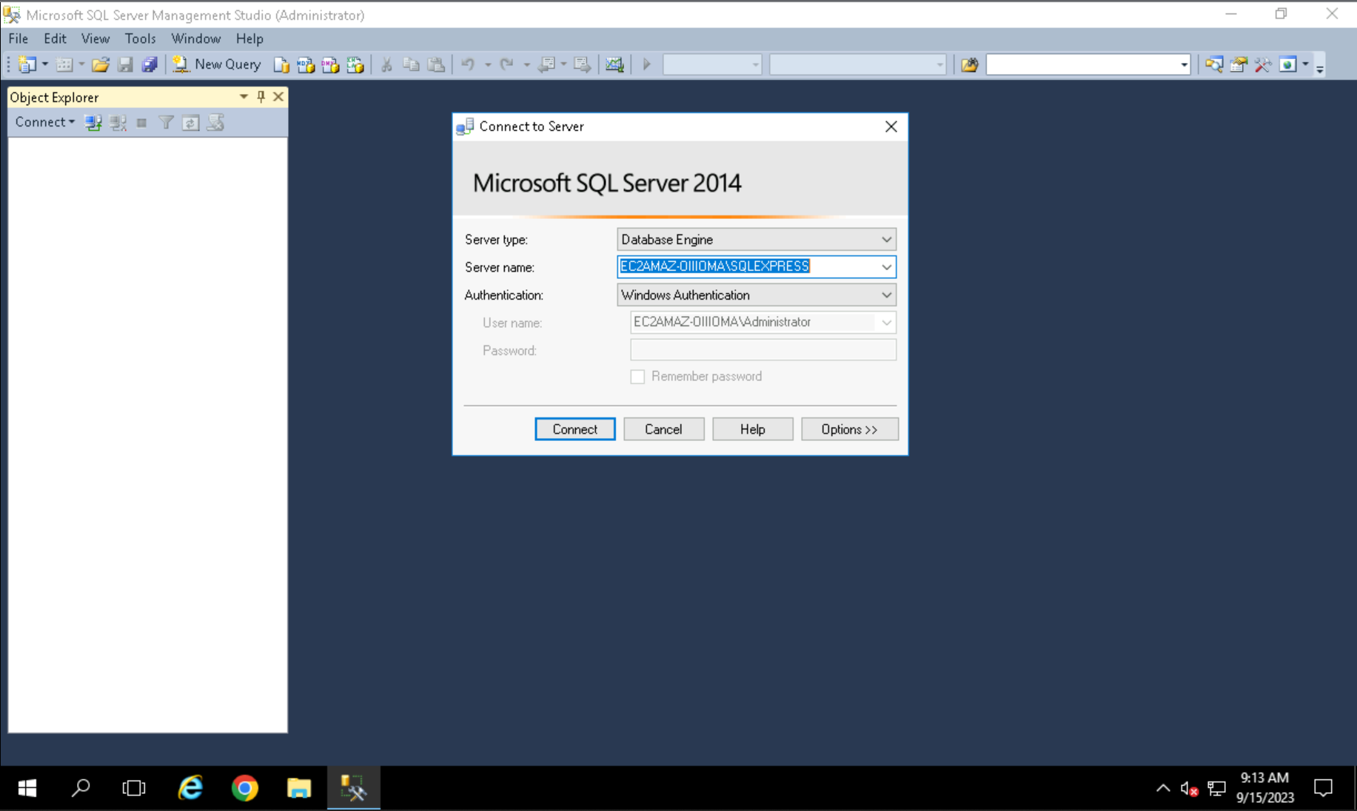

Step 3: Once connected expand *Database* folder and Click on the ***New Query*** button to enter the SQL Commands

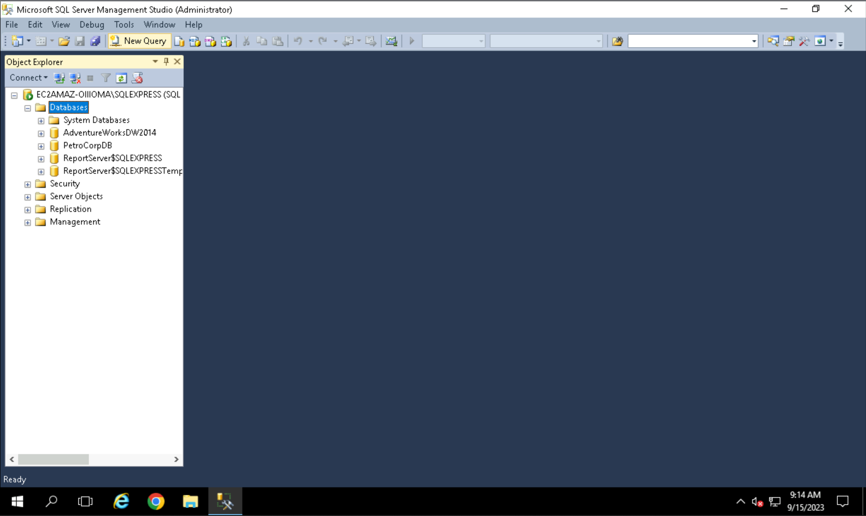

Step 4: Go to the given the link of the SQL file and copy the code and paste it in the window opened after clicking the button.

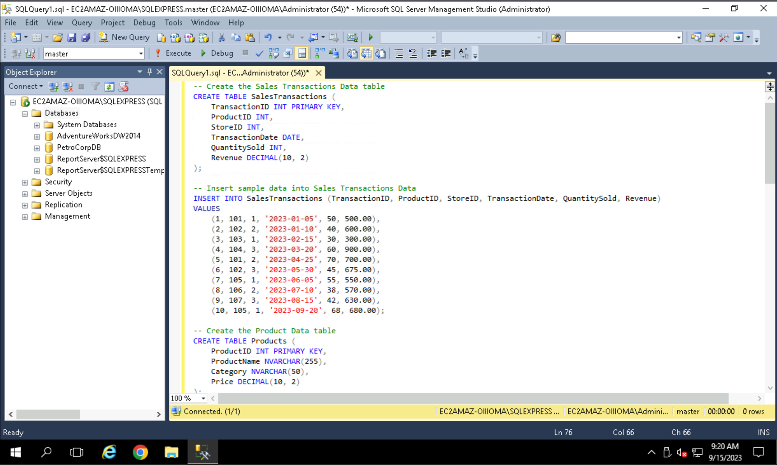

**Note**: make sure the int dropdown *master* option is selected.

Step 5: Once code has been copied click on the execute and wait for it to execute it successfully.

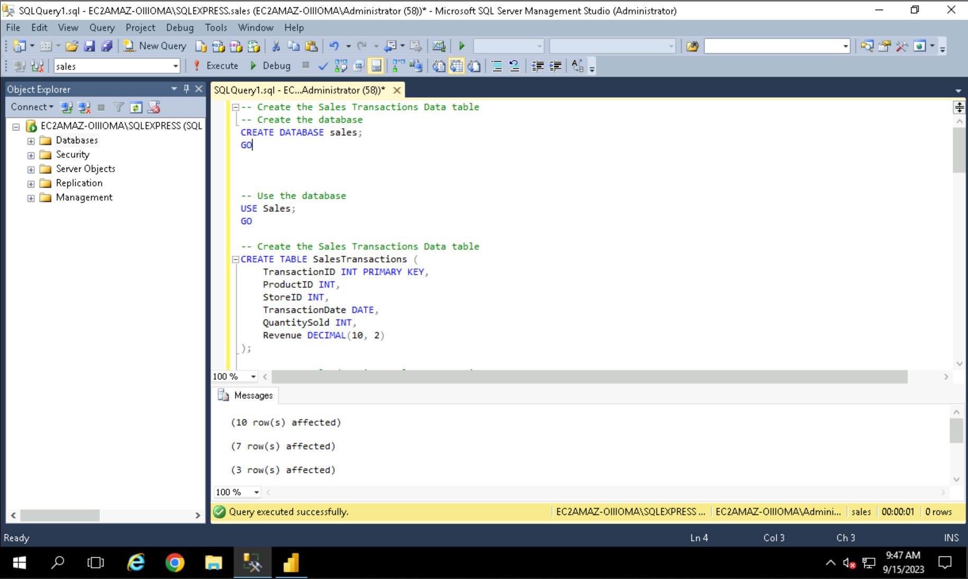

Once it is executed successfully, you can see the number of rows affected.

Step 6: Now open the Power BI.

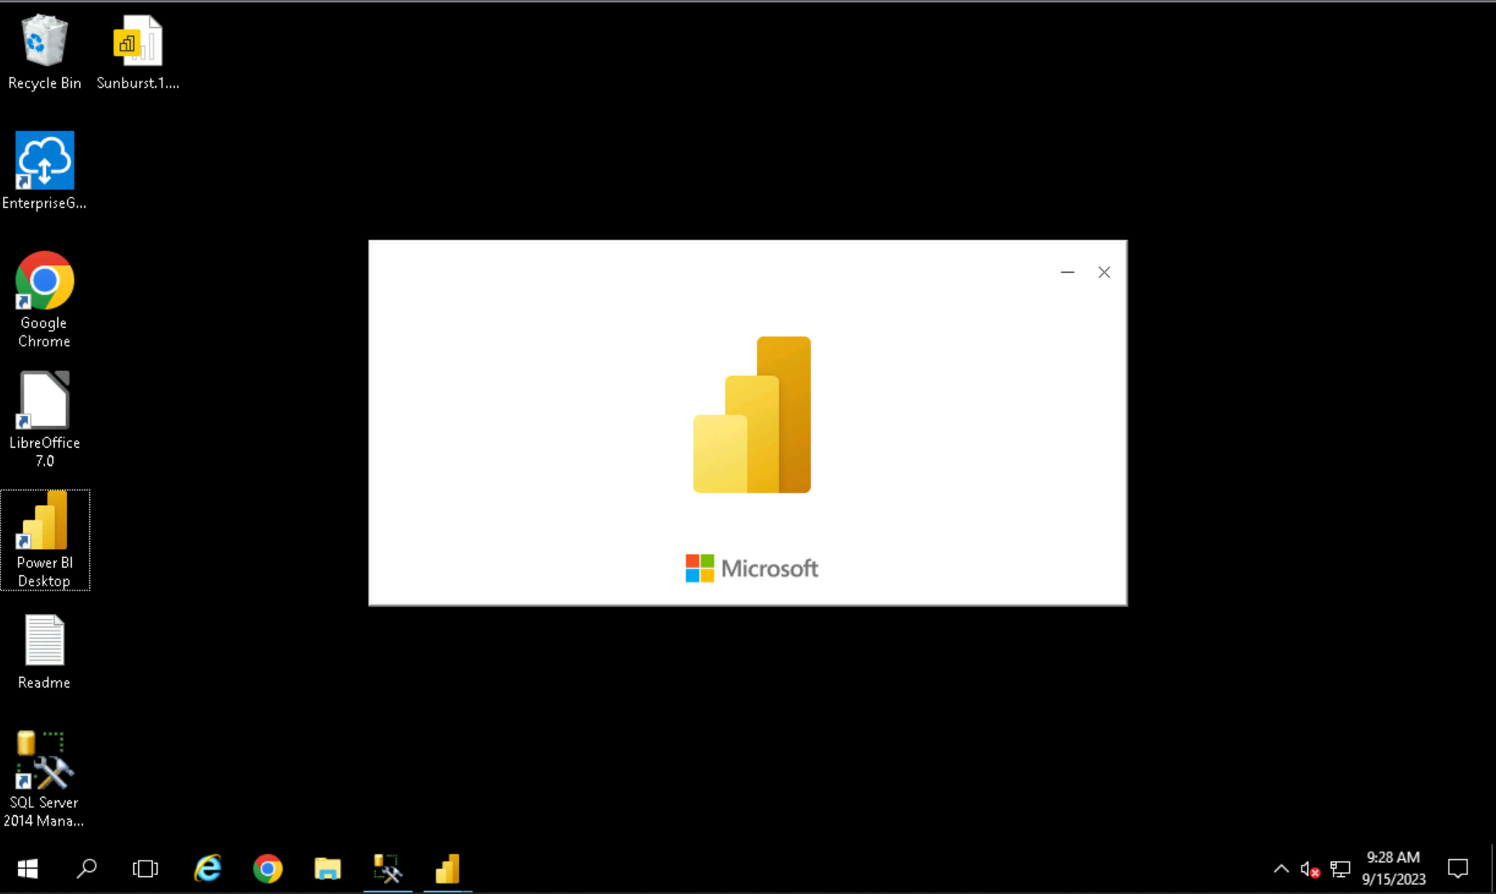

Step 7: Once it gets opened, click on the ***SQL Server*** to load the data from the server.

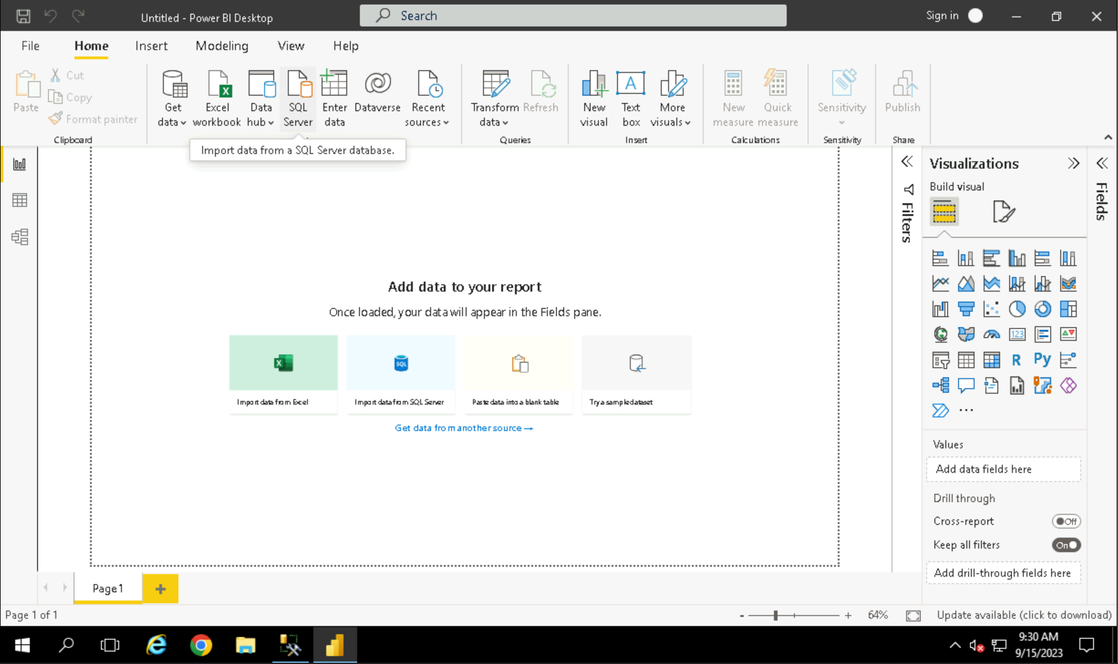

Step 8: Enter the Server name and click on OK to open a new window containing all the databases and tables.

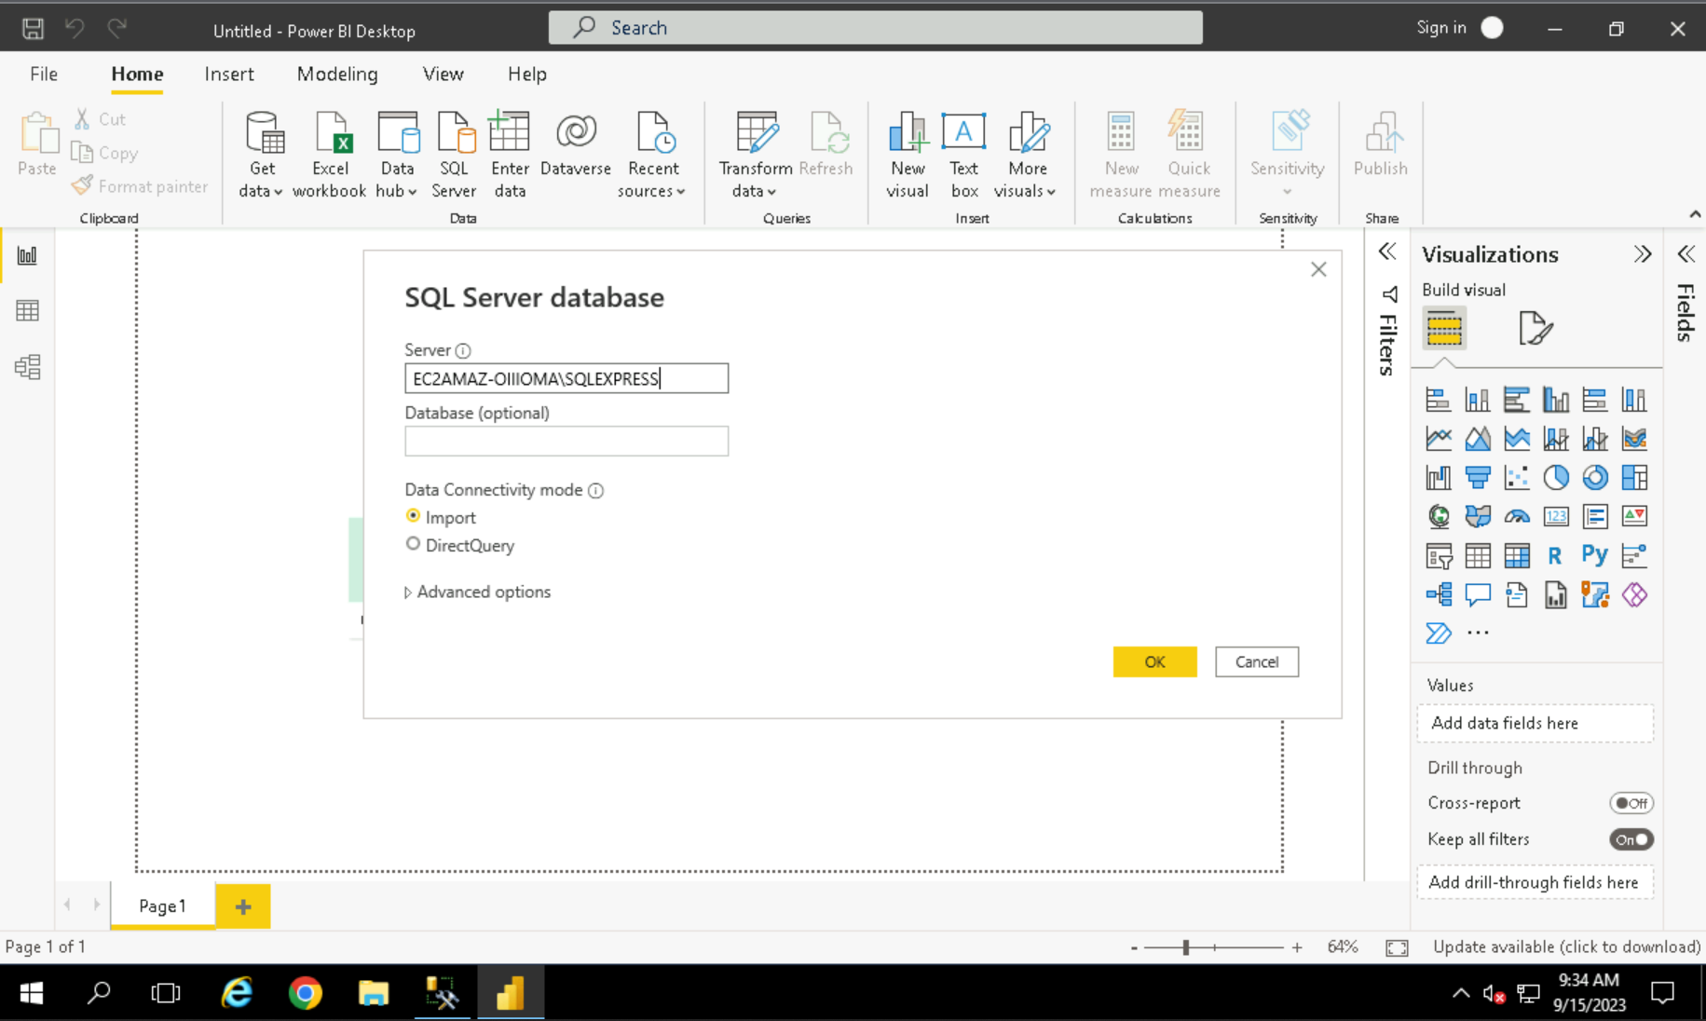

Note: Make sure that connectivity option for the server is in **Import** mode.

Step 9: Select the ***sales*** database to expand and view the tables in it.

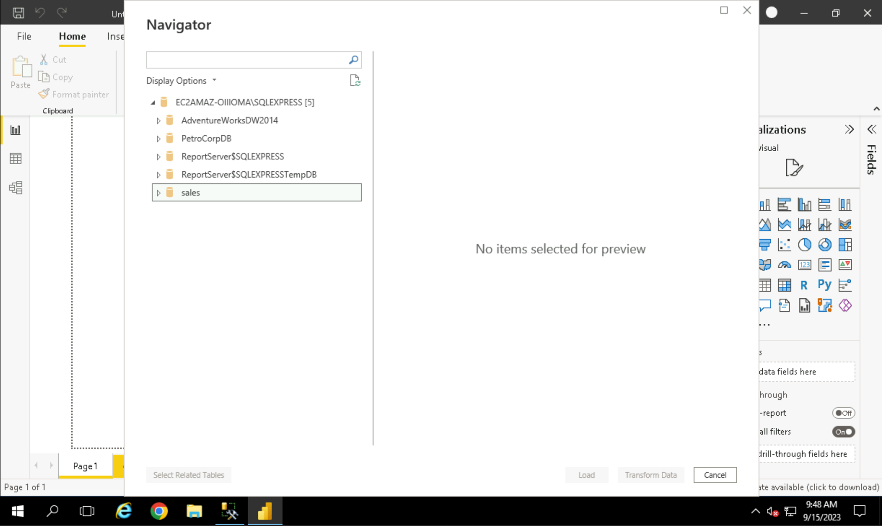

Step 10: Select the desired tables from the list of tables and click on ***Load*** to load the data.

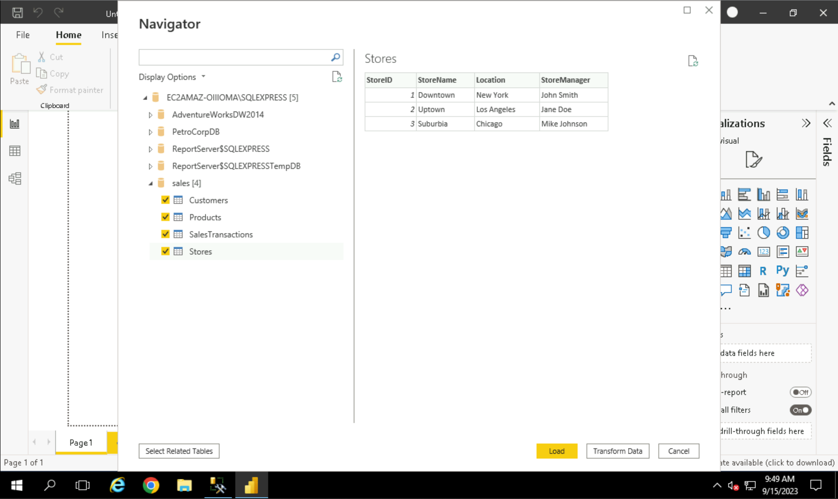

Step 11: Once you click on the button it will start loading the tables into the power BI and it will look like this.

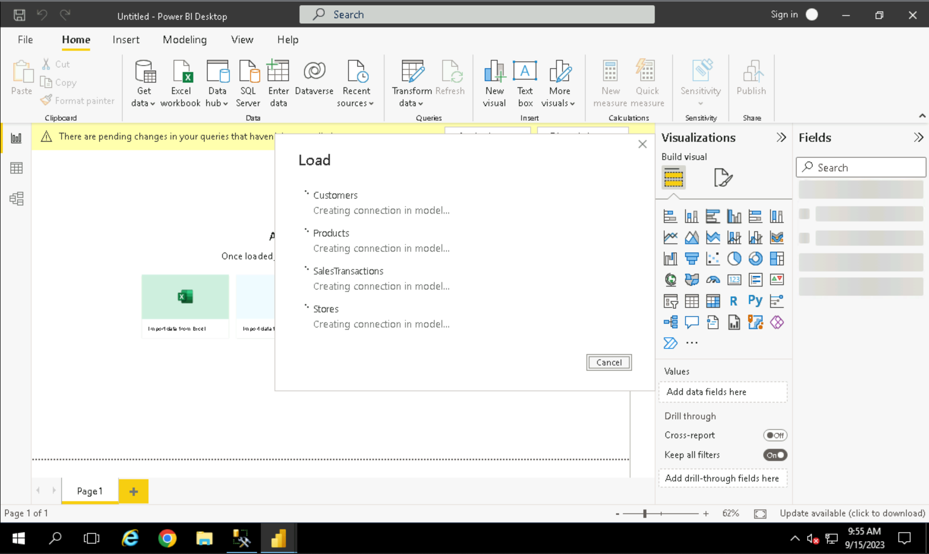

Step 12: Once the tables have been loaded, you can see the relationship between the tables by clicking over the ***Model*** tab.

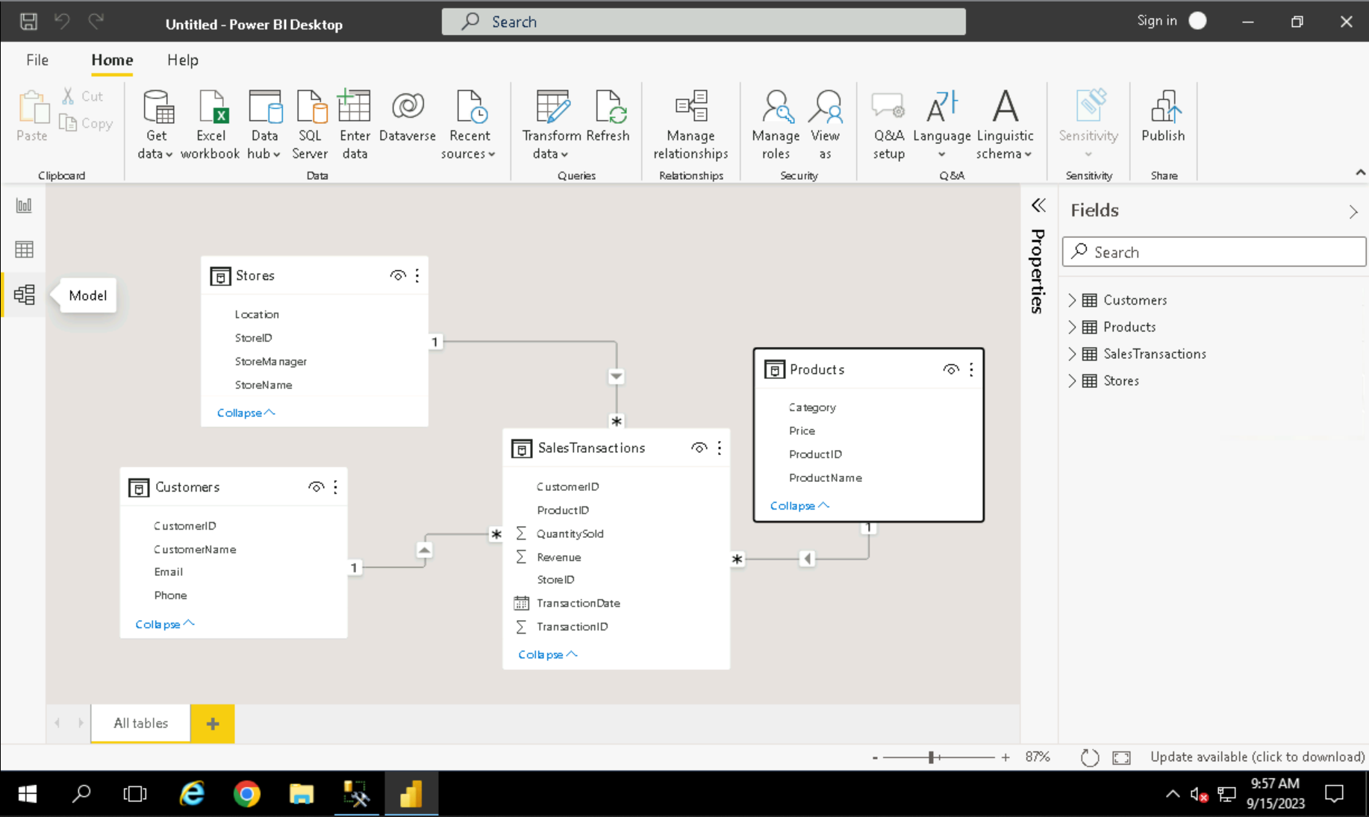

# Data Transformation

To transform any data, click on the ***Transform Data*** button. Once we click on that a new ***Power Query Editor*** Window will open to perform all the operations.

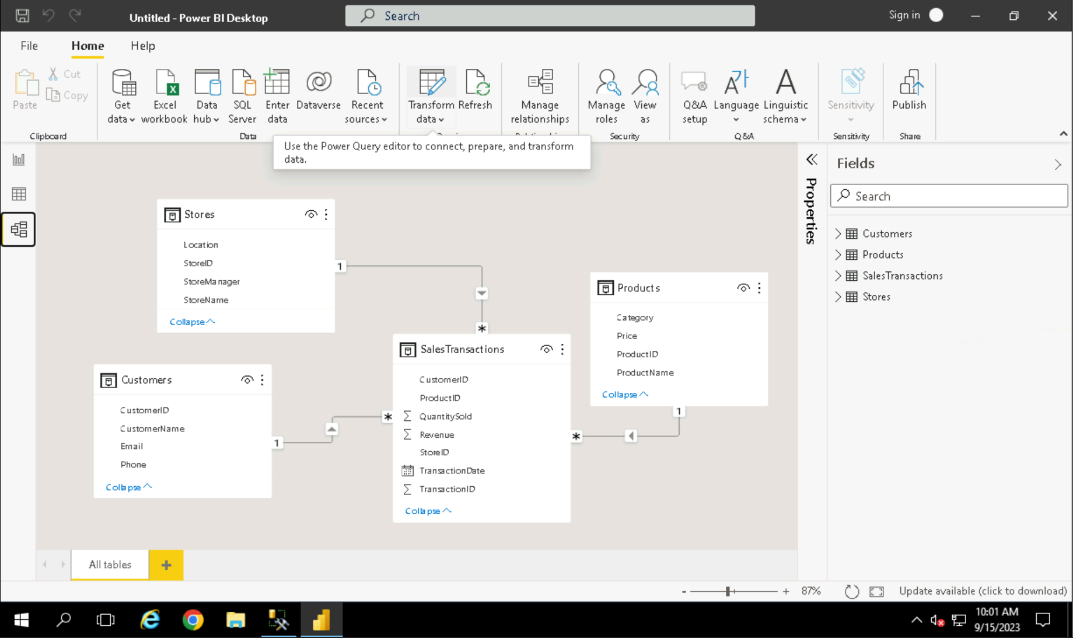

## Merging of Tables.

Step 1: To merge two Tables, click on the ***Merge Queries*** option present in the ***Merge Queries*** option inside the ***Combine*** button.

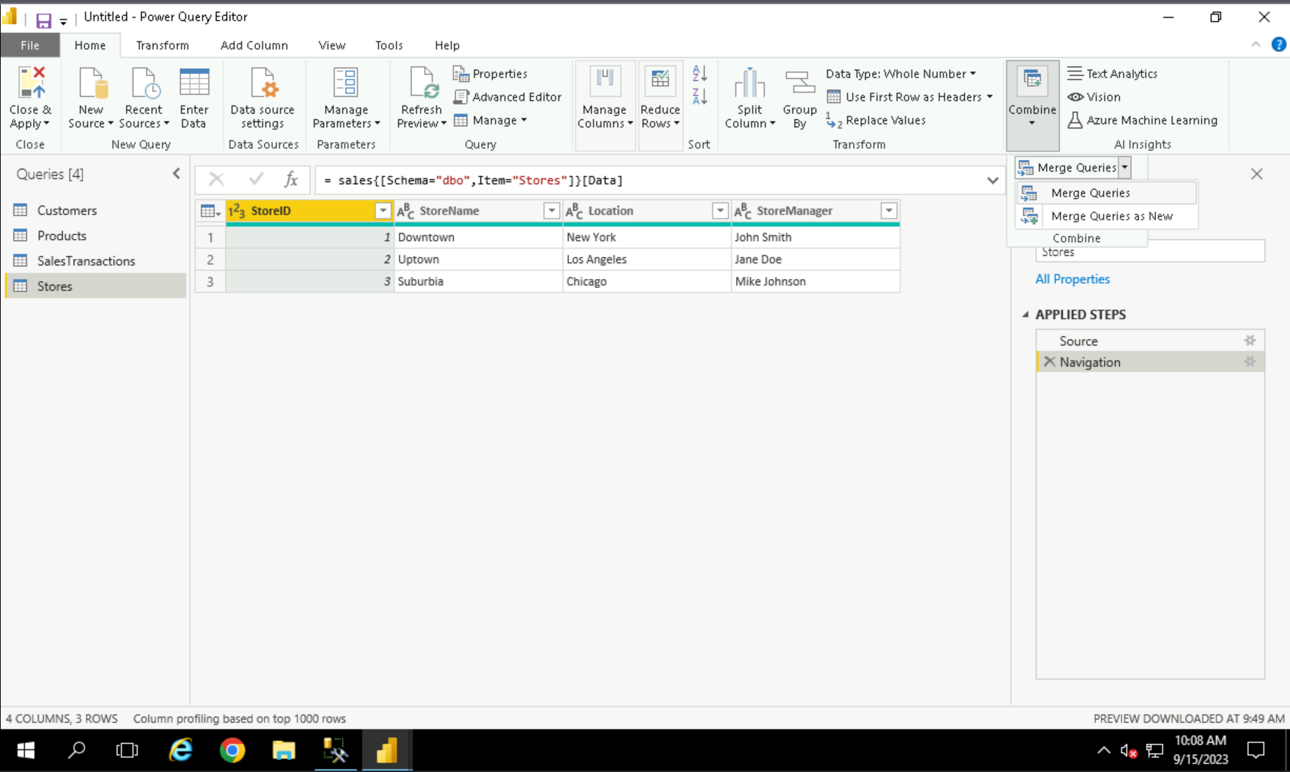

Step 2: Once the merge queries option is clicked, it will open a modal containing drop downs of table names. Select the table name and the column on the basis of which you want to merge the tables. Once they are selected click OK to merge the tables.

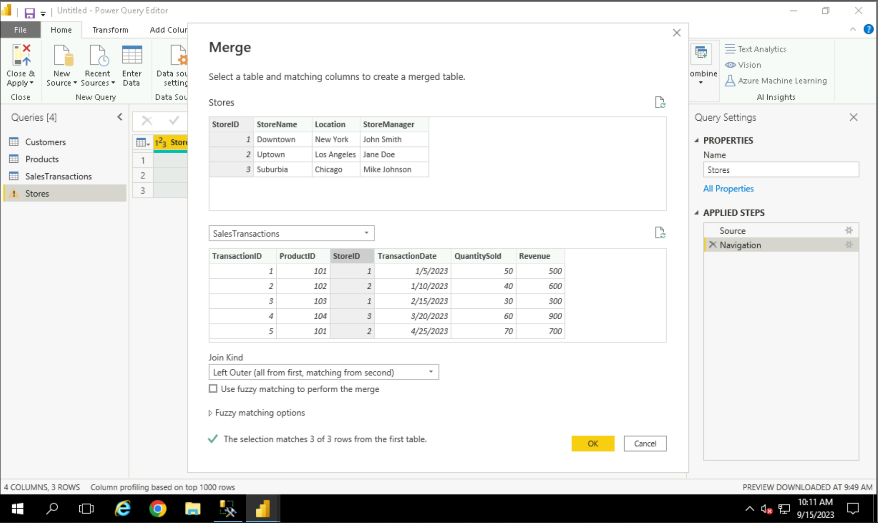

Step 3: Click on the circled button to select the columns you want to display into the table. And also uncheck the last checkbox to not include the table name as a prefix.

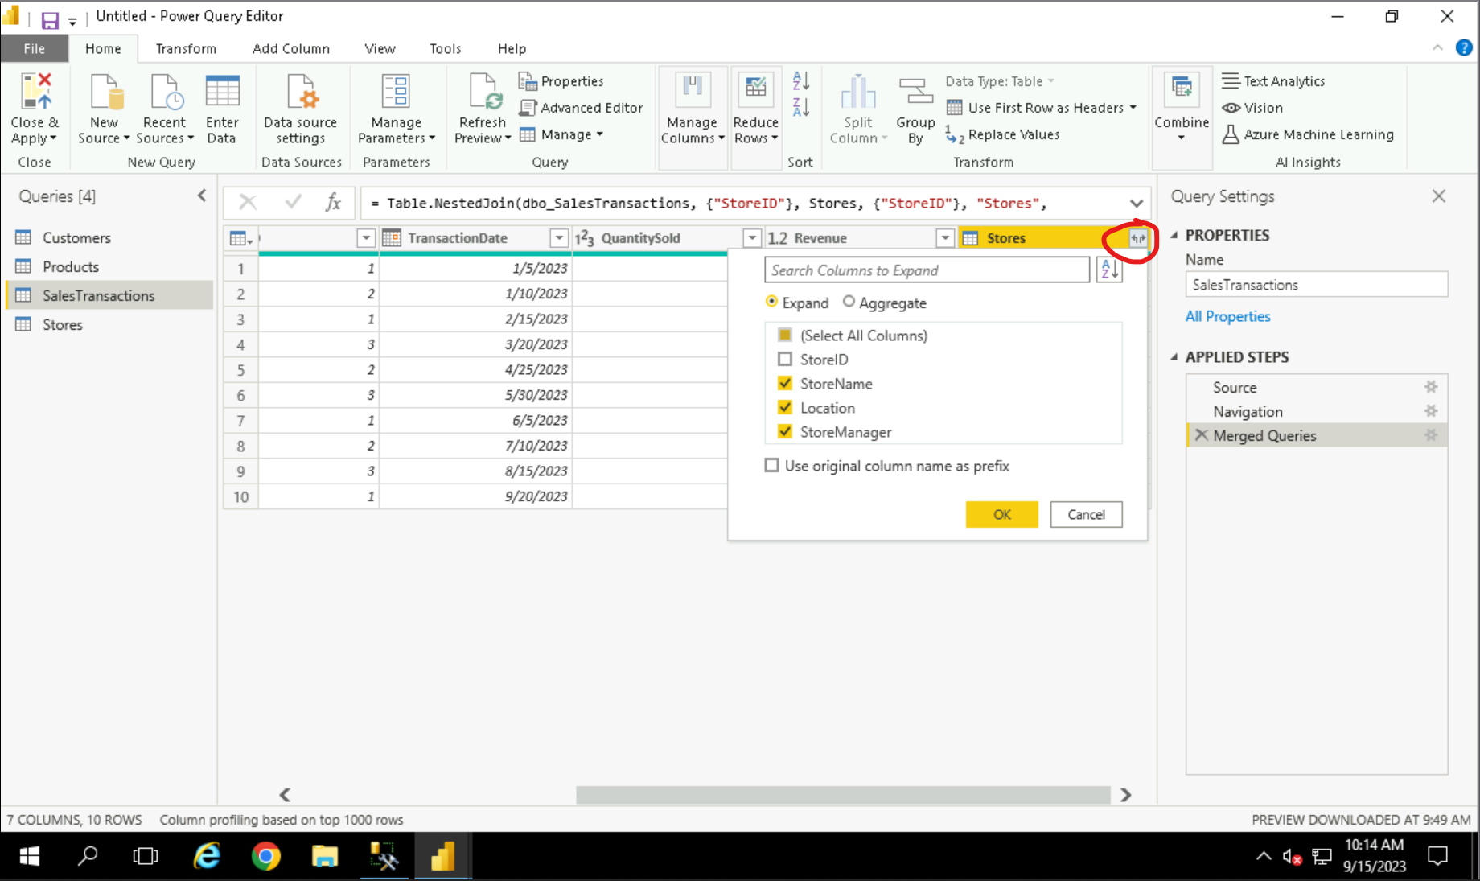

## Clean Data

To clean the data click on the dropdown present near the column name cell to unselect the null values if present.

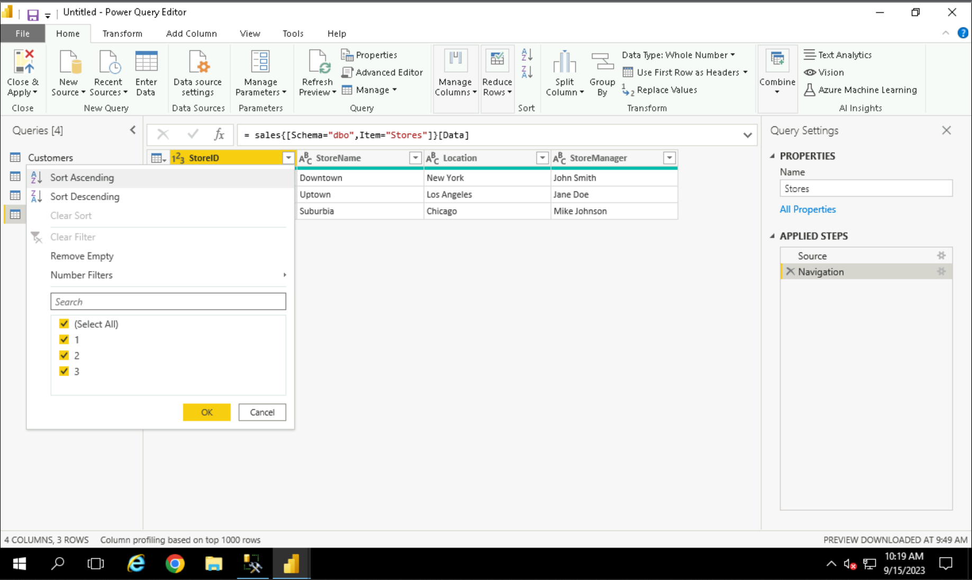

## Calculated Columns

To add a calculated column we first need select the columns that we have to calculate. We selected the ***Quantity Sold*** and ***Price*** column and go to ***add column*** *tab* and select the ***multiplication*** column. A new column will be created and rename it to the desired name.

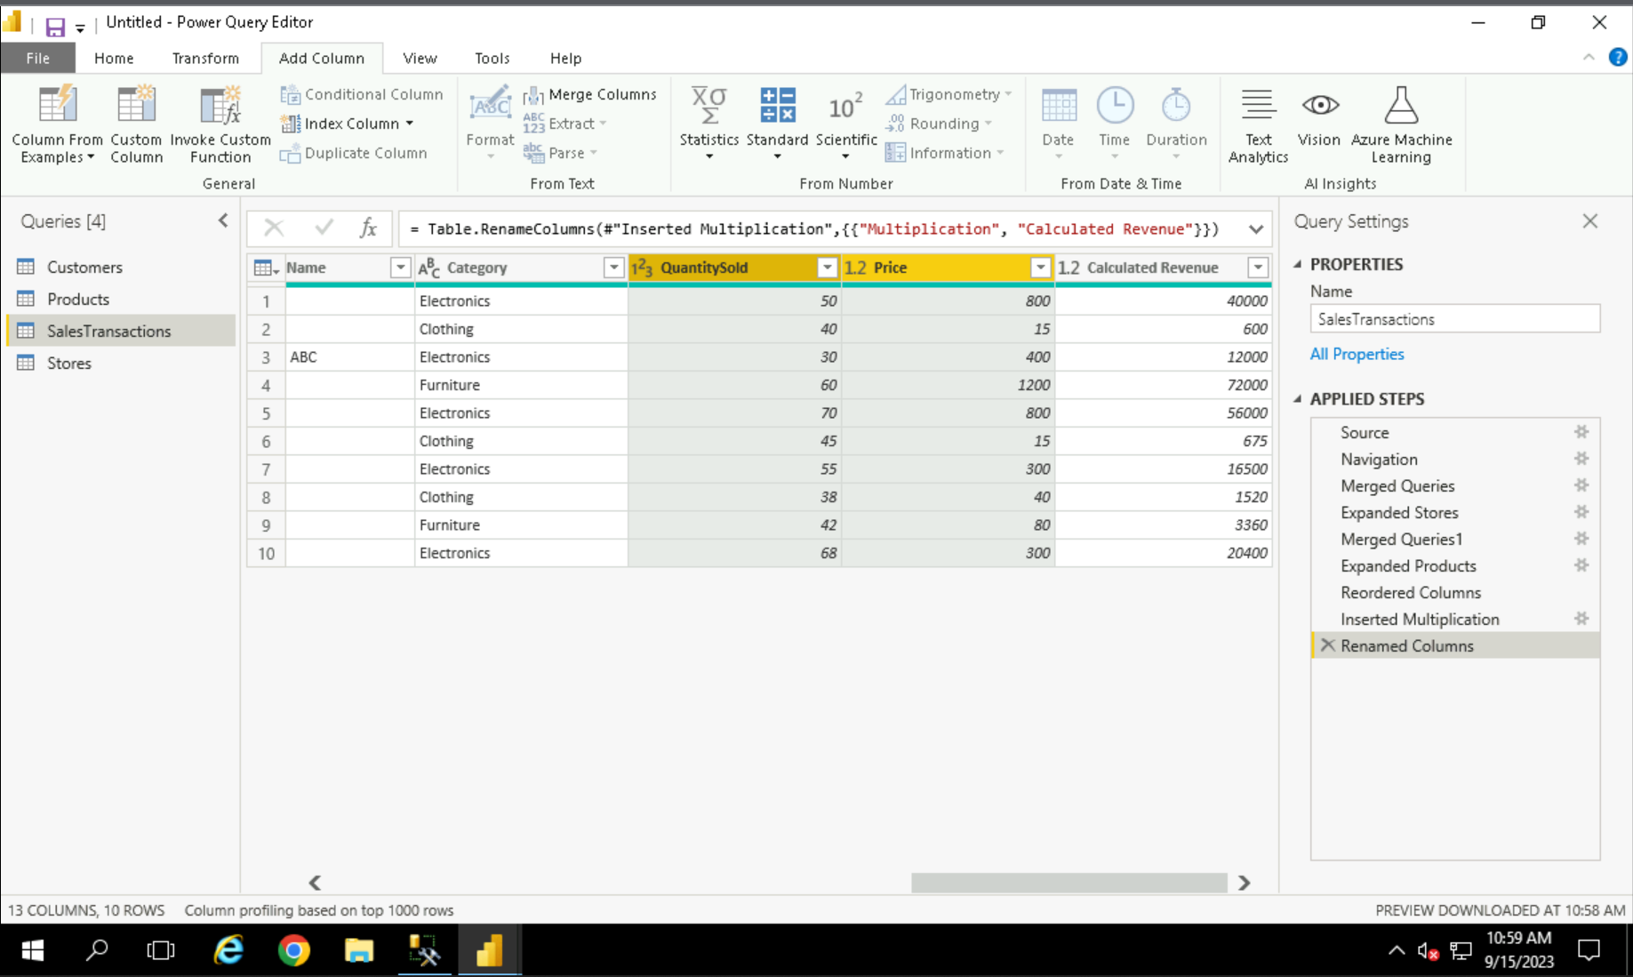

## Filter Data

To find the specific set of data, we use the filters. To do that, click on the transform data option and to apply filter in the specific table follow the steps stated below.

Step 1: To filter the data on the basis of the transaction date we select the ***Date filters*** option and click on the ‘*In the Previous’* option.

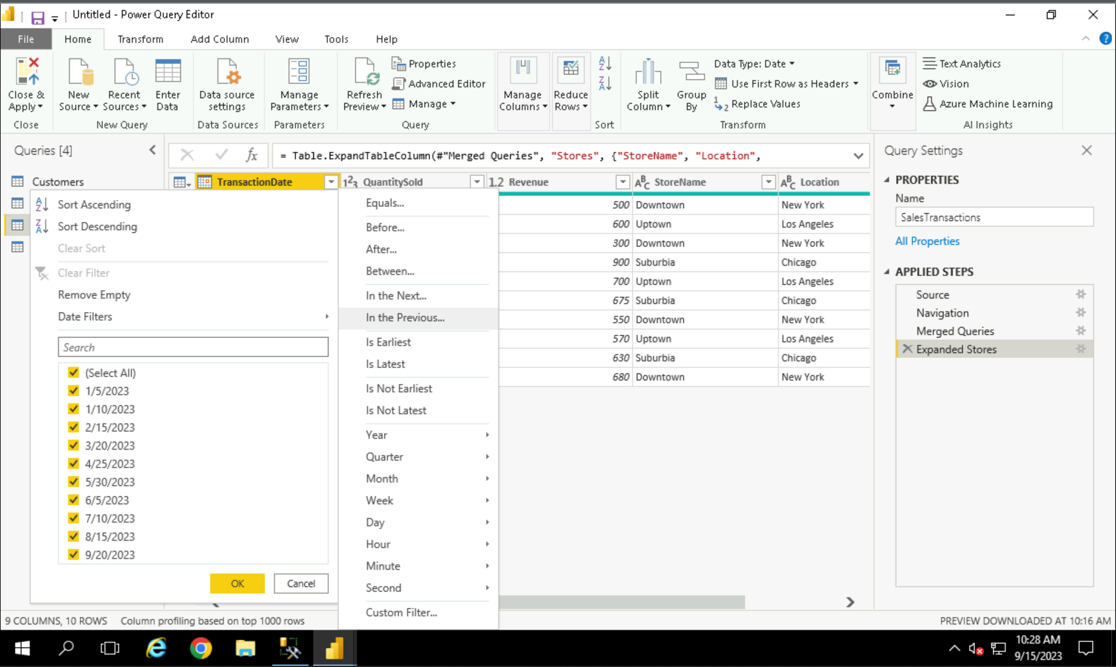

Step 2: Once we select the option, it opens a new modal to enter the number of days or date before which transactions are required.

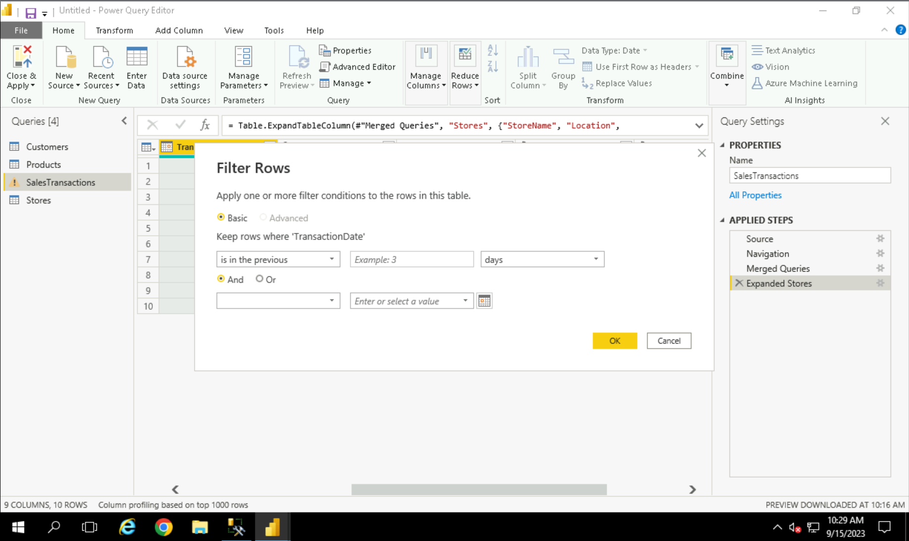

Step 3: Let’s enter 1 and select the month option from the dropdown and click on OK to see if there are any transactions previous month.

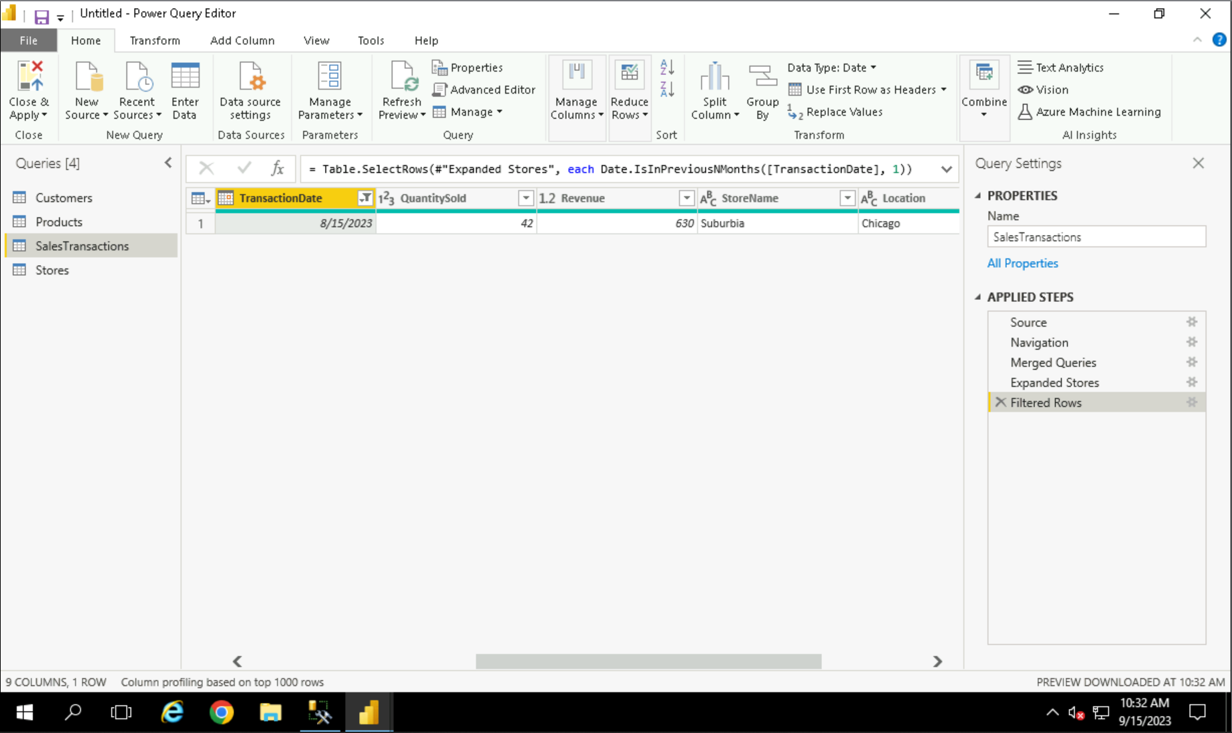

Once everything is done, select on close and apply to update the changes in the table.

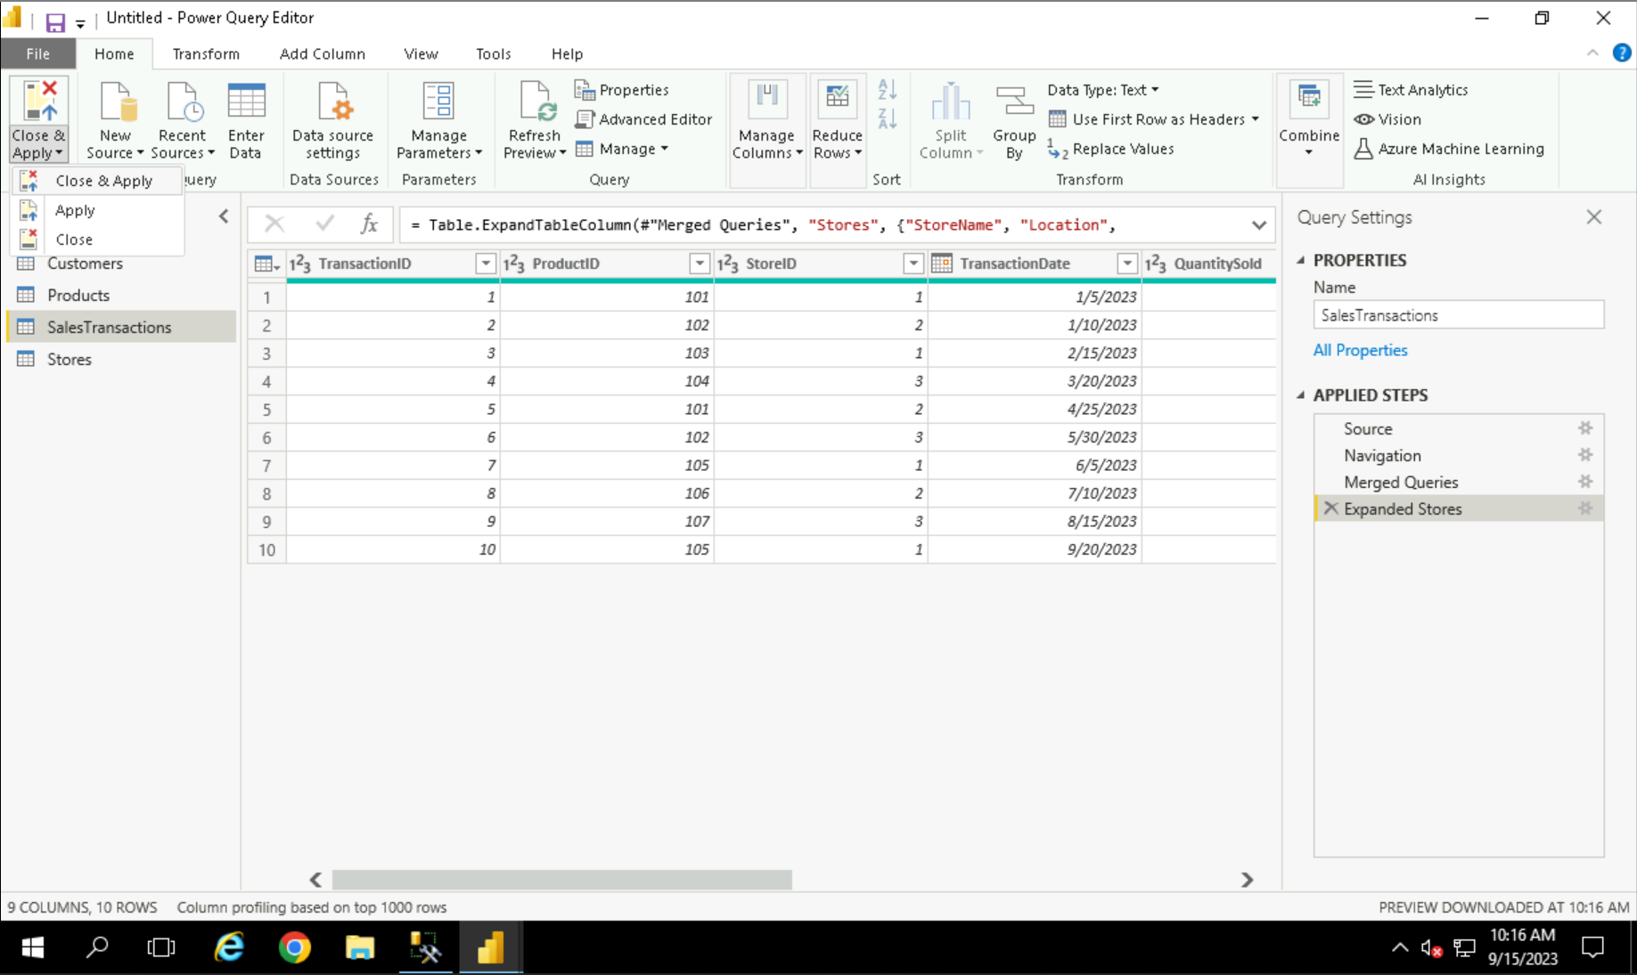

# Data Modelling

Step 1: Go to the Model Tab

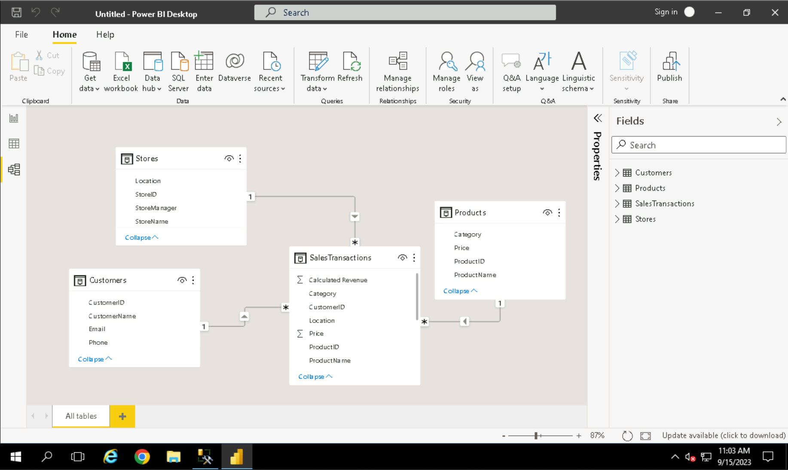

Step 2: Click on the ***Manage Relationship*** button.

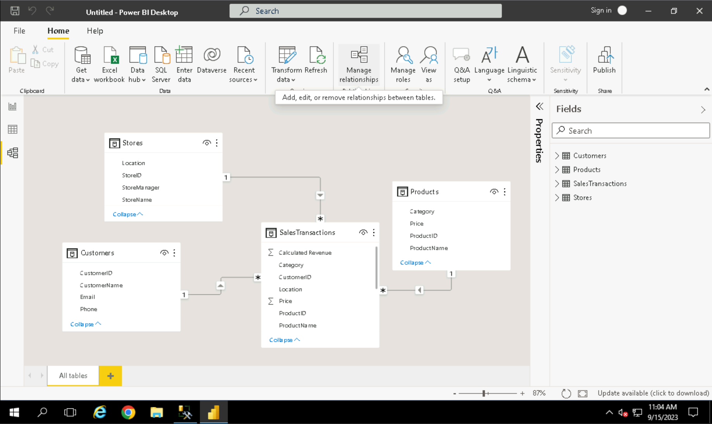

Step 3: Click on New to create a new relationship

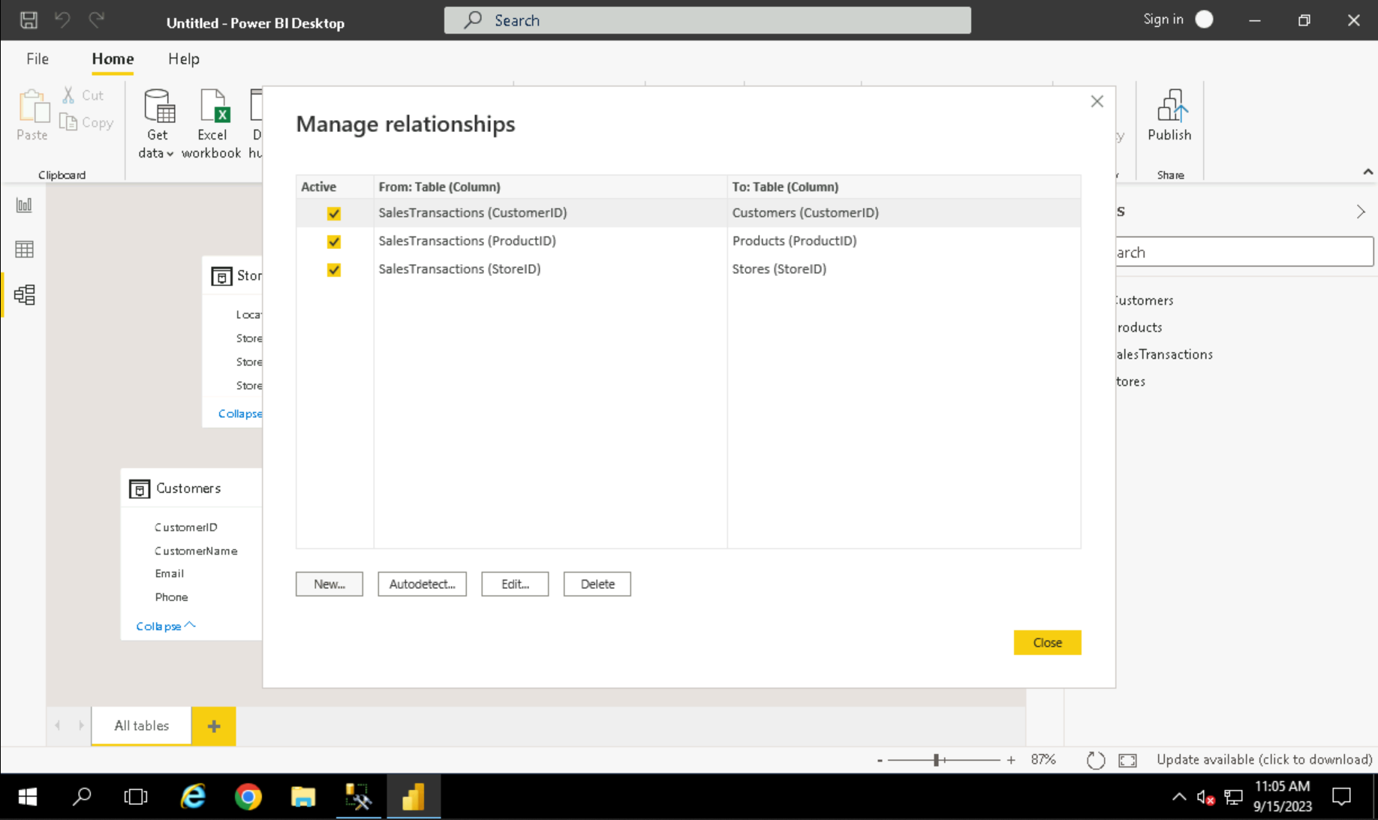

Step 4: Select the tables for which you want to form the relationship and also the column on the basis of which the relation will be formed.

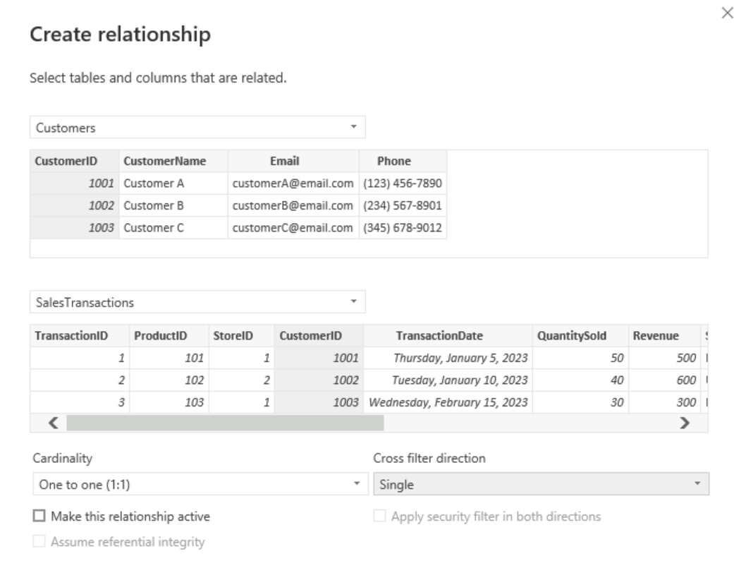

# Visualization

1. 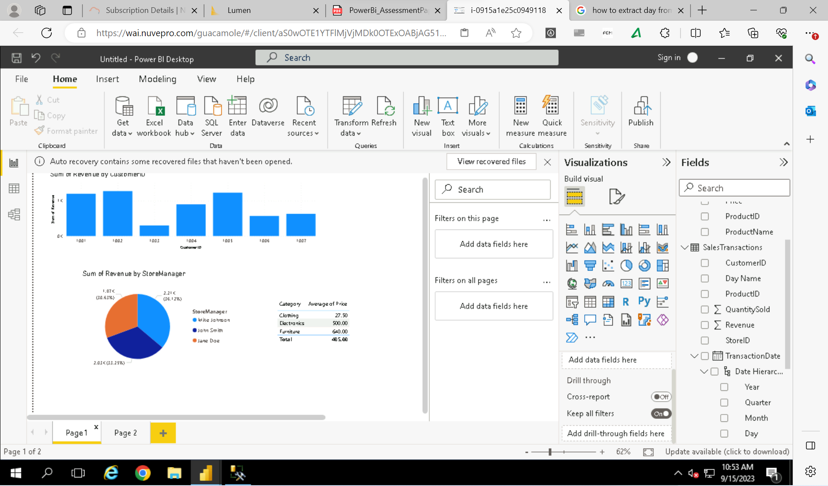
2. 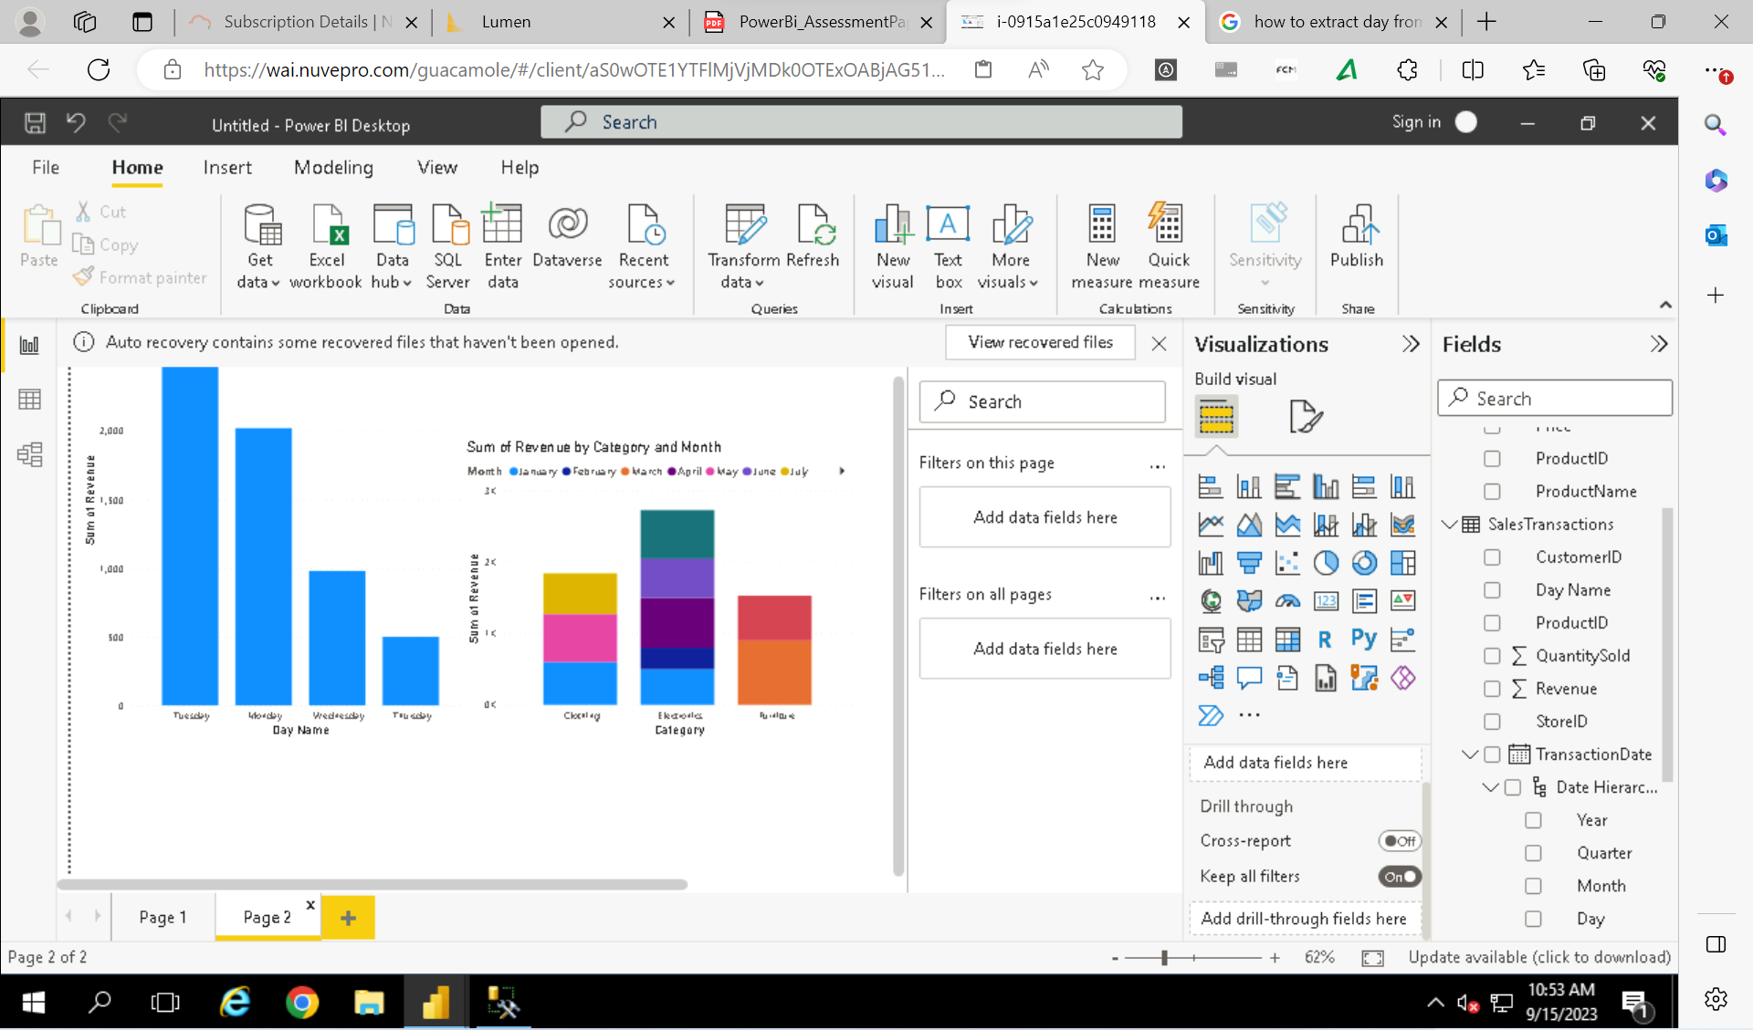

# Summary

